Practical Gaming 2024

# Anna Kovalenko

# T00243622

# Big Adventure

# Gameplay

W – Move Forward

A – Move Left

D – Move Right

S – Move Back

Space – Jump

R – Through a ball in a basketball mini game

T – Talk with NPCs

F – Open treasure chests

Mouse Left – Hit Enemies, Sell items

Mouse Right – Defence

Mouse position is a position of the camera

Teleports to move between game locations

Inventory system to store collectable items

Collectable Items:

1. Apples
2. Bones
3. Diamonds
4. Fish
5. Keys
6. 6.Rocks

Other items:

1. Mushrooms – to give damage to the player
2. Heart – to give health to the player

NPCs:

1. Haruko - at the start/end of the game
2. Sellers – to sell collectable items and get experience (located in the castell city)
3. Enemies – to fight with the player
4. Animals – to make game more real

# Coding

Under each of the following headings, please describe the concept, why is it or isn’t it useful/needed, where do you implement in your project, you may provide screenshots or cut and past code segments etc..

* Frame Rate Independence

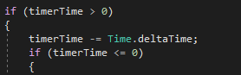

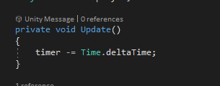

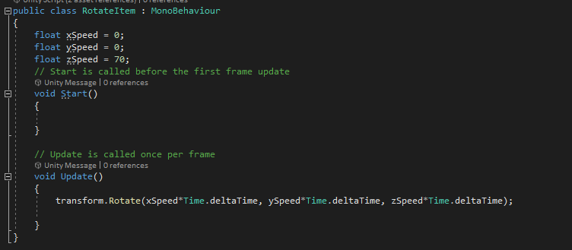

* Interfaces

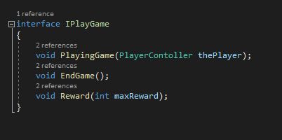

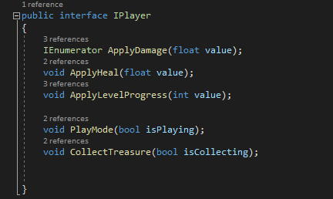

* Inheritance

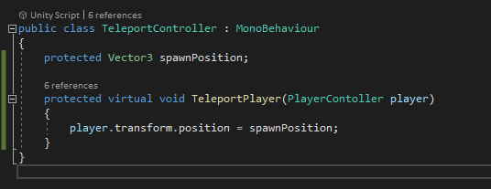

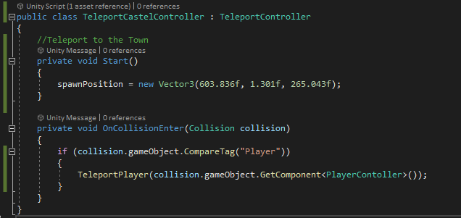

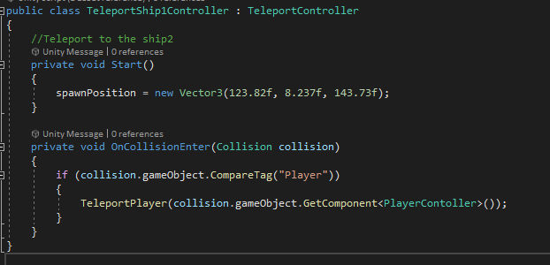

* Case pattern //(swich/case)

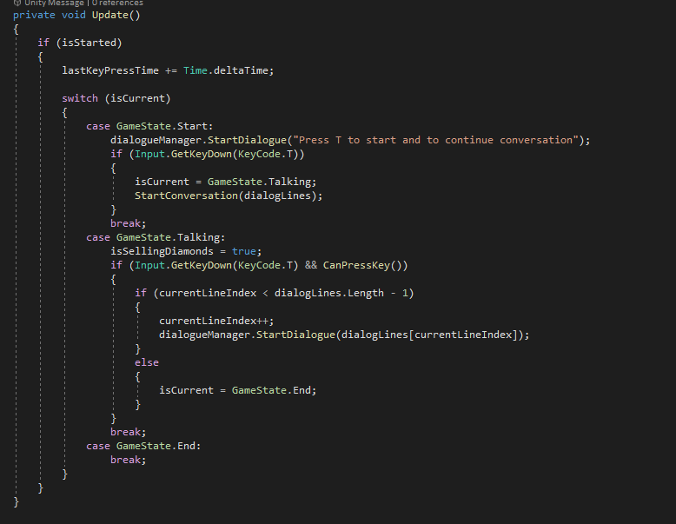

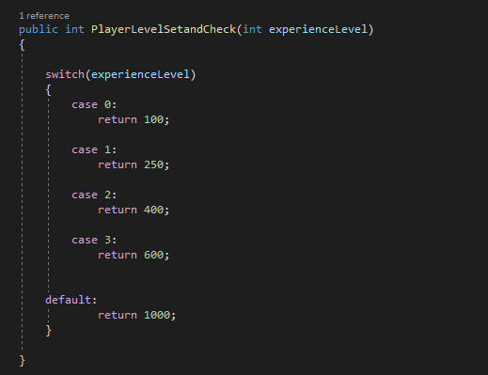

* Observer Pattern

Example1:

* + BasketballMiniGame Script

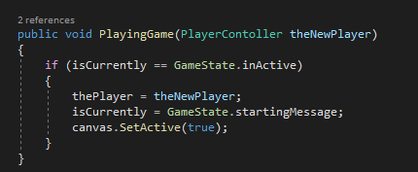

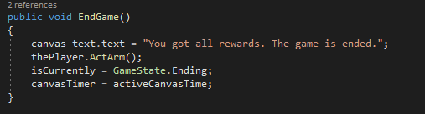

* + PlayerConttroller Script

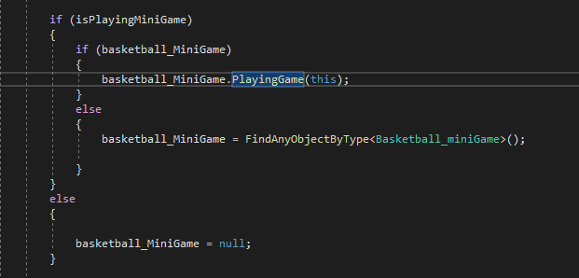

Example 2:

* DialogManager Script

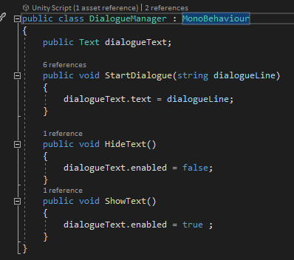

* NPC_Controller Script

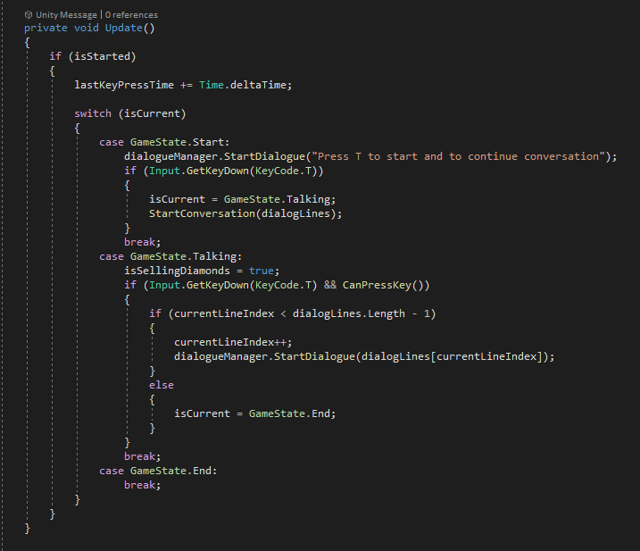

* Polymorphism
  + Interface IPlayer

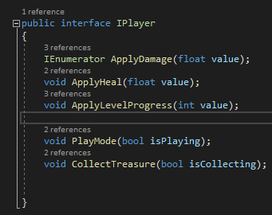

* + PlayerController Script

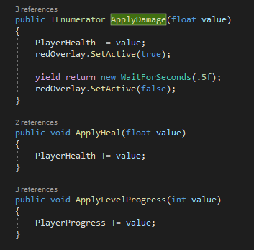

* Communication between scripts/game objects

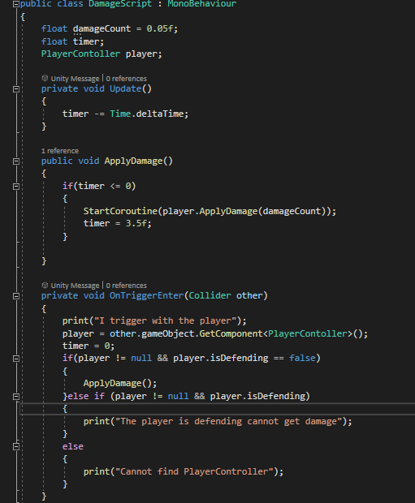

Exapmle 2:

* EnemyController Script communicate with the player

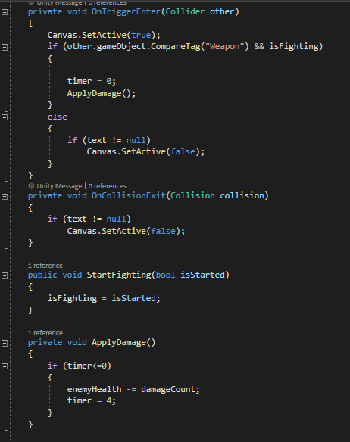

* Instantiation and Prefabs

GameController Script

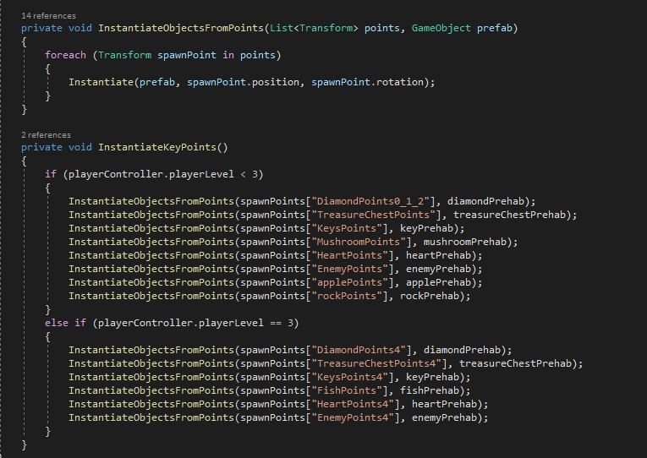

* Magic Numbers

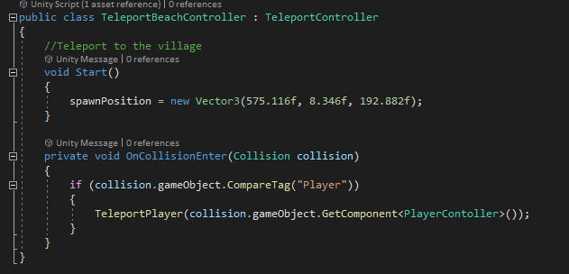

* Model Animation
  + Player Animation Model

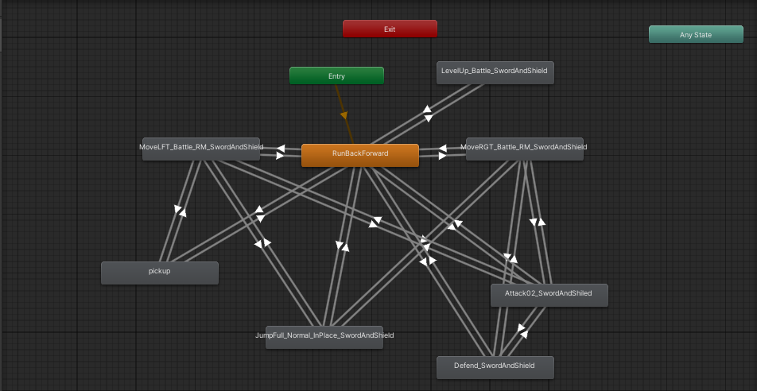

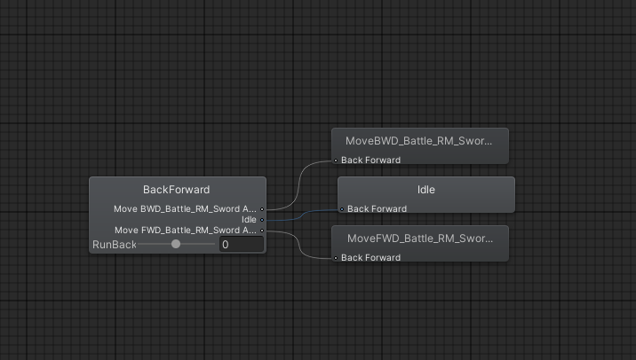

* Self made models and or animations

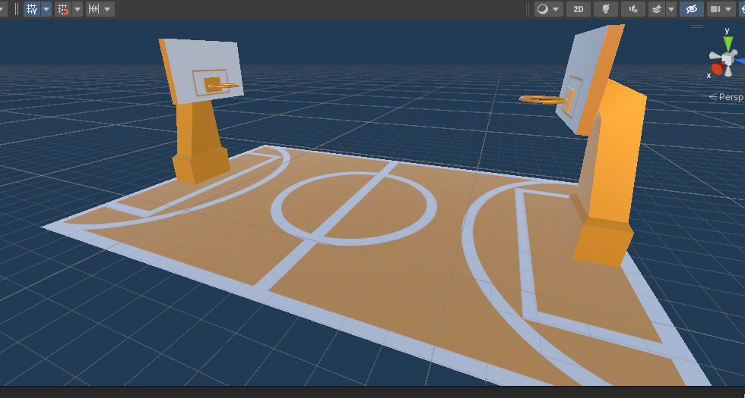

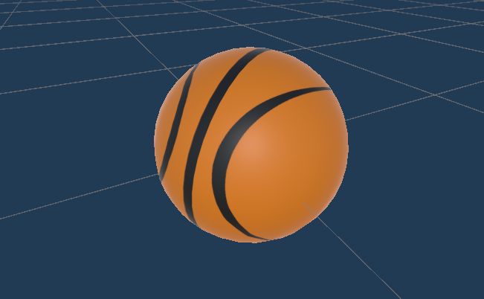

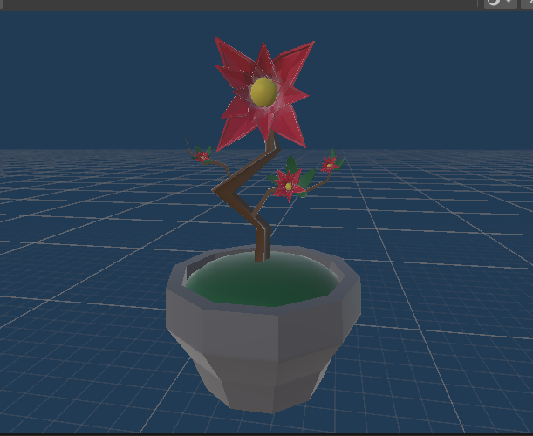

* Interactions between objects/scripts
  + PlayerController Script

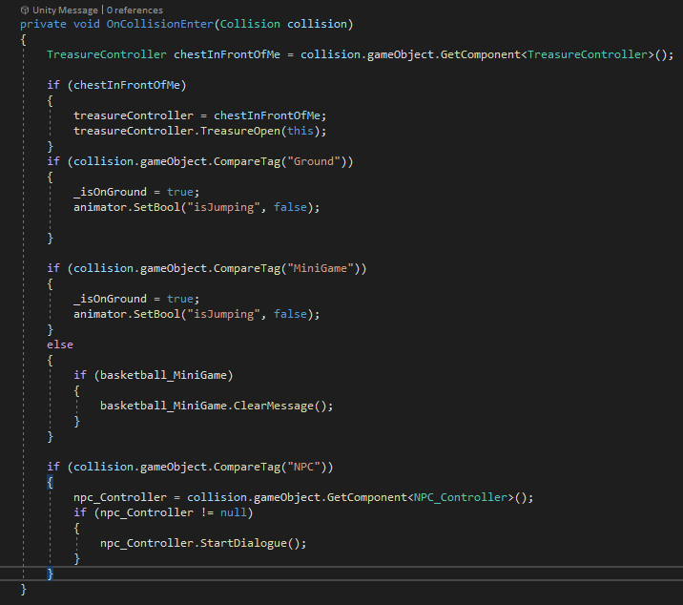

* Propper code placement

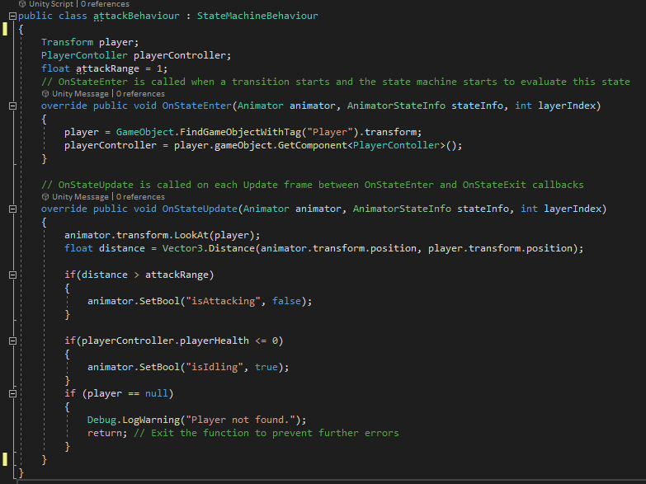

* Code repetition

In all animation scripts for enemies



* Feature 1
  + Player Movements

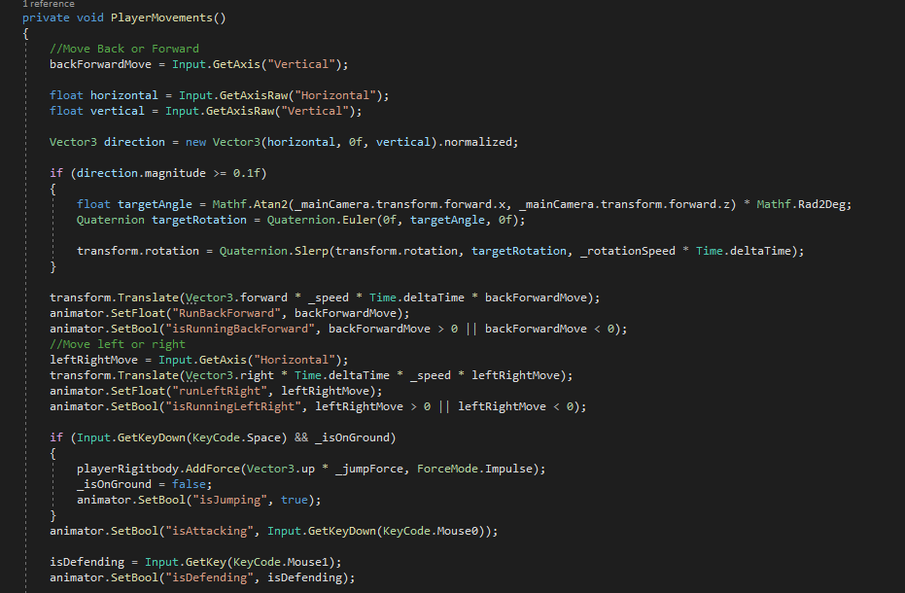

* Feature 2
  + Inventory System

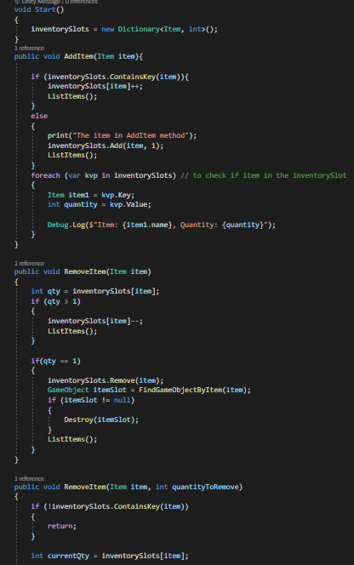

* Feature 3
  + Dialog System with NPCs

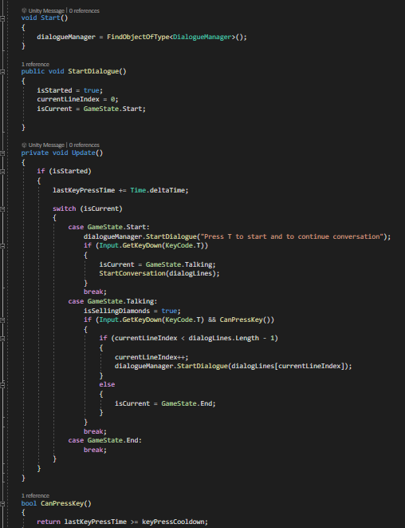

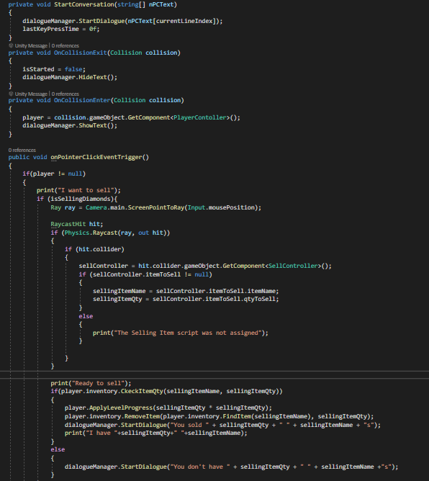

* Feature 4

User Interface



